**THE THEORY OF LOOPING TIME: A RESEARCH REPORT**

**Disclaimer:**

This is just a 13 year old expressing his stupidly over-imaginative thoughts. Next to no amount of professional research has been conducted for this so it is requested to take this presentation light heartedly. Think of it more as a kid being unsure of his surroundings and asking help from his elders understanding it.

Please don’t see it as a waste of time or as a joke. Me, the writer is very serious about this report and wants the reader to straighten my mind related to this doubt. If possible, the reader is requested to correct me of all inaccuracies made in this paper.

Thank you for your time.

Regards,

Tanmay Gupta, 8-E, Roll.no:26,

Delhi Public School Whitefield.

**Preview:**

**Abstract:**

This paper explores the speculative hypothesis that time, as the fourth dimension, may loop within a higher-dimensional framework, potentially enclosed in a five-dimensional space. By integrating concepts of cyclic cosmology, the nature of time as a dimensional construct, and the analogy of looping dimensions, this hypothesis attempts to unify these ideas into a single theoretical framework. While this proposition is highly speculative, it provides an imaginative lens to examine the universe's structure and behaviour.

**Introduction:**

The nature of time and its role in the universe has long been a subject of fascination. Current cosmological models suggest that time began with the Big Bang, a singularity that marked the universe's inception. However, theories like cyclic cosmology propose the possibility of recurrent phases of expansion and contraction. This paper builds upon these ideas by suggesting that time itself may loop, akin to a spatial dimension, and that this looping behaviour could be embedded in a higher-dimensional (5D) space.

**Background concepts:**

1. **Time as the Fourth Dimension:**  
   In Einstein’s theory of relativity, time is treated as the fourth dimension, interwoven with the three spatial dimensions to form a four-dimensional space-time continuum. Unlike spatial dimensions, time exhibits an "arrow" dictated by entropy, distinguishing past, present, and future. The hypothesis here extends this concept by proposing that time, like spatial dimensions, may exhibit a looping behaviour within a higher-dimensional framework
2. **Cyclic Cosmology**  
   Cyclic cosmology posits that the universe undergoes infinite cycles of expansion (Big Bang) and contraction (Big Crunch) in a time loop. To illustrate, imagine a rubber banding being stretched and released with these two processes being stuck in a time loop. Meaning, that after the rubber band contracts the time frame resets to the start where the rubber band was originally in a contracted state, from where it is stretched and contracted again. Just to repeat the time loop. This analogy helps us visualise how the time loop occurs in the universe. Though observational evidence from the research ‘The New Cyclic Cosmology ‘ (Steinhardt and Turok) currently supports the universe's accelerating expansion, this theory provides a foundation for exploring the possibility of a time loop. For the purposes of this hypothesis, we assume cyclic cosmology to be valid.

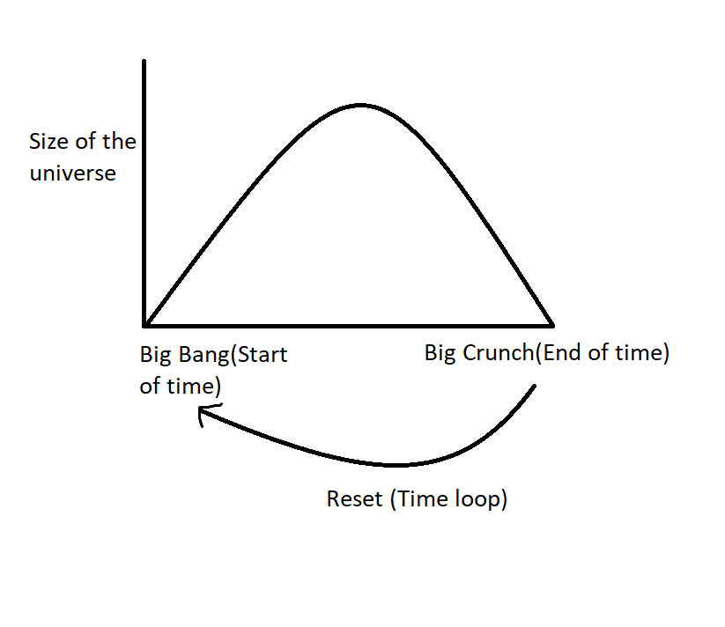

1. **Looping Dimensions:**   
   Looping dimensions are exemplified by a two-dimensional plane enclosing a three-dimensional object, such as the Earth's surface enclosing its interior. To make this clearer, consider two individuals, A and B. A is stuck in a perfectly flat 2D plane, which extends infinitely. B, however, is on a 2D plane that wraps around a 3D sphere, similar to Earth's surface. While A perceives their plane as infinite, B eventually loops back to their starting point after walking in a straight line. This analogy suggests that our 4D space-time may similarly loop within a higher-dimensional (5D) structure.

**Main Theory:**

The main theory suggest that as we saw in the looping dimensions concept, a 2D plane was actually just enclosing a figure of larger dimensions since it looped and returned to its original starting point. Applying a similar analogy with time, as a 4D construct, may loop when embedded in a higher-dimensional (5D) space. This looping behaviour could explain:

1. A cyclic universe where each "Big Bang" originates from the collapse of the previous universe’s energy into a singularity.
2. The continuity of time while allowing for repetitive cycles, aligning with certain interpretations of entropy and quantum mechanics.
3. The possibility that our perception of time as linear is an artifact of our 4D perspective.

**What does this mean for us?**

This theory is highly far-fetched and speculative. However, this theory can only be theorised since we’ve taken a huge assumption of saying that time can exist in loops. The fact is that the truth leans more towards the literal opposite of this theory. But, since mankind has discovered only so much, we can still not confirm anything, giving rise to theories like these. This theory might or might not add a new perspective while studying quantum physics or cosmology. This being said, I would also like to say that this fabricated theory of mine could lead to some crazy, mindboggling theories like supporting alternative timelines & universes and many more. With the highly unlikely event of this theory being true, the 5th dimension could add a significant landmark in human history.

**CONCLUSION:**

This hypothesis presents a speculative yet intriguing framework for understanding the universe’s structure. By considering time as a looping dimension within a 5D enclosure, it bridges ideas from cyclic cosmology, dimensional looping, and higher-dimensional theories. While significant challenges and gaps remain, this theory invites further exploration and discussion.

**References:**

* Einstein, A. (1915). General Theory of Relativity.
* Penrose, R. (2010). Cycles of Time: An Extraordinary New View of the Universe.
* Hawking, S. (1988). A Brief History of Time.
* Steinhardt and Turok (2001-2002). The New Cyclic Cosmology

Thank you.

-Tanmay Gupta